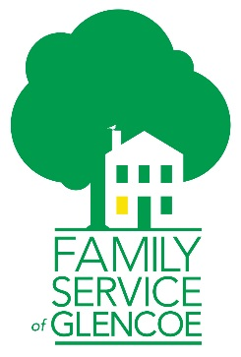
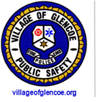
Glencoe Cares
Better serving Glencoe’s residents

----------------------------------------------------------------------------------------------------

Dear Glencoe Resident,

We are excited to share with you a new program created by Family Service of Glencoe (FSG) and Glencoe Public Safety, called Glencoe Cares, to help provide Glencoe seniors with additional support when receiving assistance from public safety.

It is important that emergency response teams have access to current medication lists, emergency contact numbers, and any advance directives established to ensure your needs and long-term wishes are being communicated.

Included in this packet, you will find the following forms:
- Emergency Contact List
- Current Medication List
- Practitioner Order for Life-Sustaining Treatment (POLST)

Please contact Emily Mysel, LCSW, at 847-835-5111 if you would like assistance in completing the paperwork.

Fondly,

Family Service of Glencoe and Glencoe Public Safety
Officer Julie Freund
Lieutenant Matthew Esposito
Emily Mysel, Senior Program Manager

